**Bug 1**

**Addition malfunction**

**Bug Summary:** Calculator's addition function doesn't work properly; it adds 2 to the correct answer

**Environment/URL:** <http://dev-qwallity.herokuapp.com/calculator>

**Operation System:** Windows 10

**Version**: 1

**Browser:** Google Chrome (Version 104.0.5112.81)

**Submit Date:** 17/05/2022

**Reporter:** Seda Grigoryan

**Steps to Reproduce:**

1. Go to <http://dev-qwallity.herokuapp.com/>

2. Click on Exercises

3. Click on Calculator

4. In the field number1 input 4

5. In the field number2 input 4

6. Choose addition from the Operations drop down list

7. Click on the Calculate button

**Expected Result:** 4+4 should equal 8

**Actual Result:** Program shows wrong calculations, as in 4+4 equals 10

**Screenshot/video:**

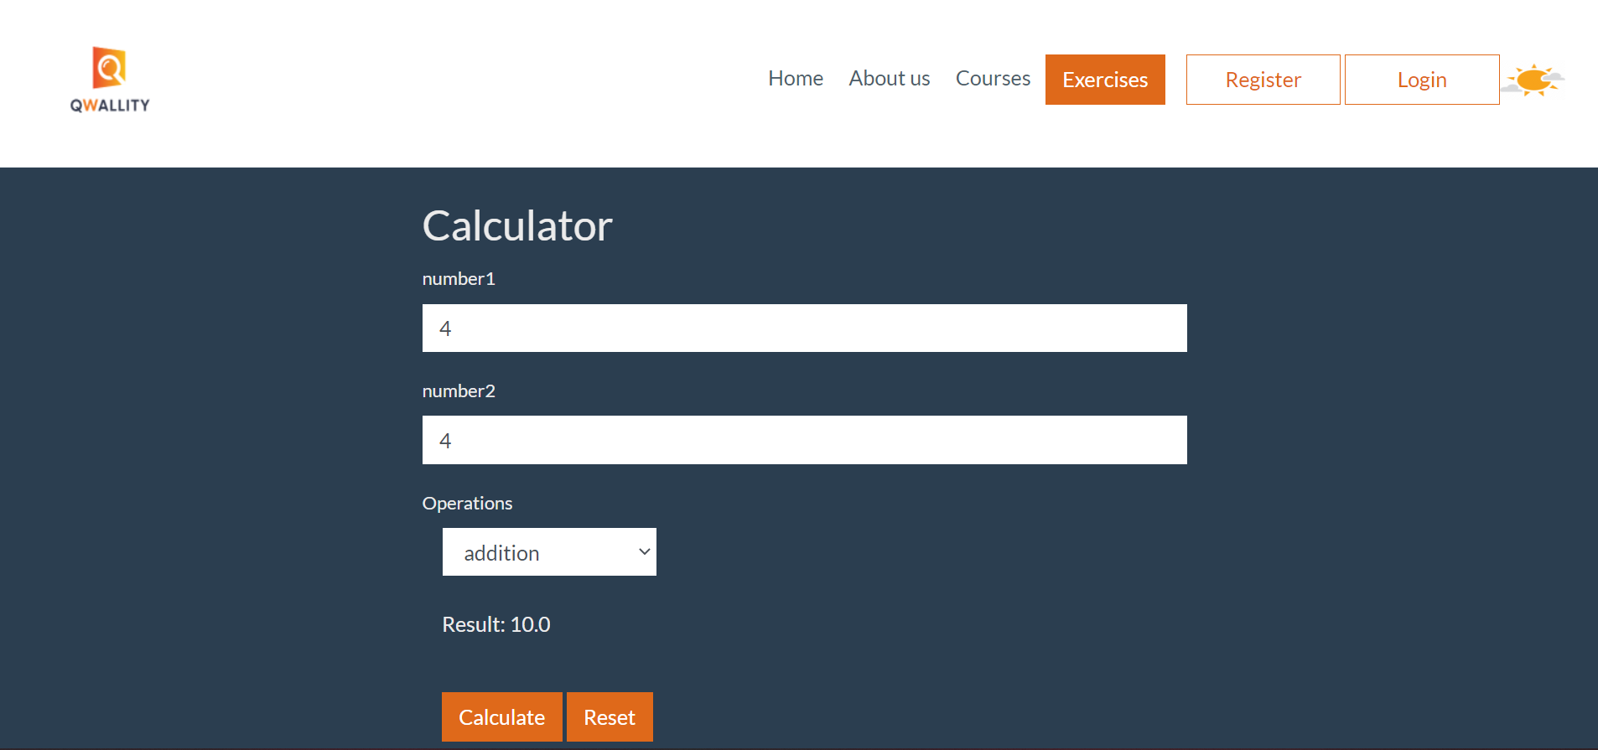

**Notes:** This is consistent for any addition operation

**References: -**

**Severity:** Critical